

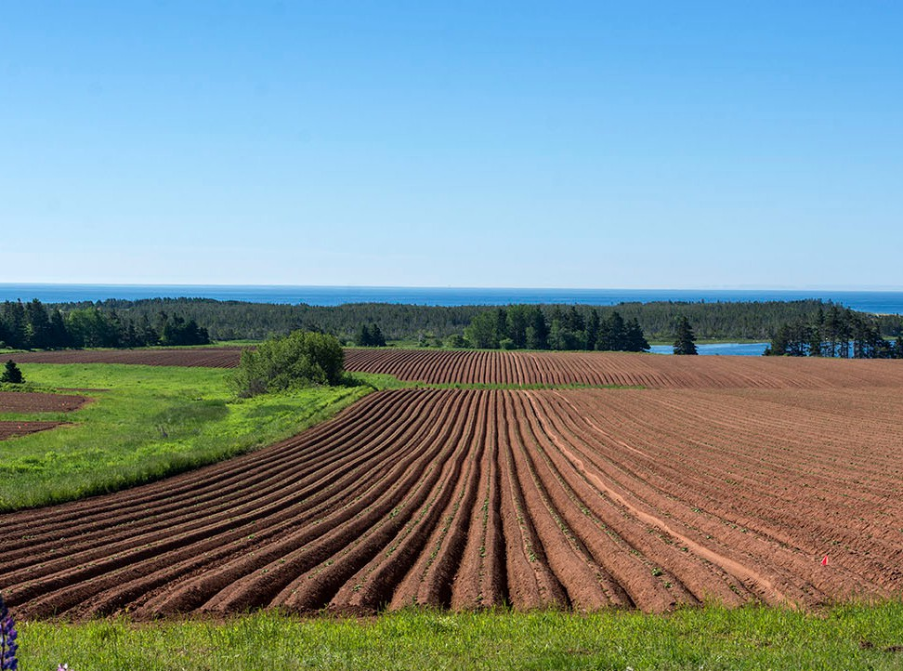

*The Prince Edward Island Potato Sector:*

AN ECONOMIC IMPACT ANALYSIS

#### Strategic Policy and Evaluation Division Department of Agriculture and Land

#### Government of Prince Edward Island Canada 2020

*[This page intentionally left blank]*

###### PEI Department of Agriculture and Land

###### © 2020 Government of Prince Edward Island

###### Strategic Policy and Evaluation Division Department of Agriculture and Land

###### 11 Kent Street, 5th Floor Jones Building, Charlottetown, Prince Edward Island, Canada

###### Data of Publication: 2020 File: 2050-10-P10

###### Contact: [agri-feedback@gov.pe.ca](mailto:agri-feedback@gov.pe.ca)

Suggested Citation

Government of Prince Edward Island. (2020). *The Prince Edward Island Potato Sector: An Economic Impact Analysis*. Charlottetown, PE: Strategic Policy and Evaluation Division, Department of Agriculture and Land.

Principle Research and Analysis

Ziad Ghaith, Ph.D. Economist

Strategic Policy and Evaluation Division

**Research Support and Advisory Committee**

Bobby Cameron, Ph.D., Director, Strategic Policy and Evaluation Division, Department of Agriculture and Land

Chelsea Morrison, Evaluation and Performance Analyst, Strategic Policy and Evaluation Division

Thea Du, Junior Policy Analyst, Strategic Policy and Evaluation Division, Department of Agriculture and Land

Lynda Ramsay, Director, Agriculture Industry Development, DAL, Department of Agriculture and Land

Lorraine MacKinnon, Potato Industry Coordinator, Agriculture Industry Development, Department of Agriculture and Land.

Kal B Whitnell, Executive Director, Department of Economic Growth, Tourism, and Culture

Jeff Collins. Ph.D., Trade and Economic Policy Advisor, Department of Economic Growth, Tourism, and Culture.

Greg Donald, General Manager, PEI Potato Board

Brenda Simmons, Assistant General Manager, PEI Potato Board

Joshua MacFadyen. Ph.D., Associate Professor, University of Prince Edward Island

Note

This study was completed by the Strategic Policy and Evaluation Division at the Department of Agriculture and Land, Government of Prince Edward Island. The author(s) have extended their best professional efforts in completing this study. The views and opinions expressed in this study are those of the authors and do not necessarily reflect the official policy or position of any agency of Government. The author(s) assume responsibility for any errors of omission, logic, or otherwise.

# Executive Summary

The potato sector is an integral part of Prince Edward Island’s (PEI) economy, culture and way of life. PEI ranks first in potato production in Canada. PEI’s potato can be found on almost every dining table in Canada, PEI’s seed and table potatoes are shipped to over 40 countries around the world. In 2019, PEI had 85,500 acres of land devoted to potato production representing the largest share of Canada’s potato acreage. PEI is expected to remain one of the largest potato-producing provinces in the coming years. The vast majority of PEI’s potatoes and potato products are shipped off-island to other provinces or exported internationally. PEI’s potatoes represent 23% of Canada’s total international exports of potatoes (average, 2009-2018). Together, PEI and Manitoba account for about 50% of Canada’s potato exports.

The overall goal of the study was to provide quantitative aggregate measures of the contributions of PEI’s potato sector to the economies of PEI and Canada. This report presents the methodology and results of the economic contribution of PEI’s potato sector (which includes farming and processing) at the provincial level and for the national economy. The study estimates the total economic impact of PEI’s potato sector using Statistics Canada’s 2016 Input-Output (I-O) tables. I-O models are quantitative economic models that represent the interdependences between different sectors in an economy. The model was utilized to measure the impact of PEI’s potato sector impact on the economies of PEI and Canada (in terms of output, Gross Domestic Product [GDP], labour income, employment and taxes).

The potato sector in PEI is a significant economic driver for the province. The analysis revealed that in 2016, the sector generated $1.35 billion in output and boosted the provincial GDP by over $527 million. In addition, the sector created 5,016 Full-Time Equivalent (FTE) jobs in the province, contributed

$240 million in wages, and generated $48.9 million in taxes. Nationally (i.e., the impact on overall Canada’s economy including PEI), the analysis showed that PEI’s potato sector generated about $1.89 billion in output, added $784.6 million to the national GDP, created 7,086 FTE jobs and generated over $73 million in taxes.

# Résumé

Le secteur de la pomme de terre fait partie intégrante de l’économie, de la culture et du mode de vie de l’Île-du-Prince-Édouard. La province se situe au premier rang de la production de pommes de terre au Canada. On trouve des pommes de terre de l’Île-du-Prince-Édouard sur presque toutes les tables à manger au Canada; les pommes de terre de semence et de consommation de l’Île, pour leur part, sont expédiées à plus de 40 pays autour du monde. En 2019, 85 000 acres de terre à l’Île étaient destinées à la production de pommes de terre, ce qui représente la plus grande superficie consacrée à la culture des pommes de terre au Canada. On s’attend à ce que l’Île demeure l’un des plus importants producteurs de pommes de terre au Canada dans les années à venir. La grande majorité des pommes de terre et des produits à base de pommes de terre de l’Île sont expédiés à l’extérieur de la province ou du pays. Les pommes de terre de l’Île-du-Prince-Édouard représentent 23 % du total des exportations internationales de pommes de terre du Canada (moyenne, 2009-2018). Ensemble, l’Île-du-Prince-Édouard et le Manitoba comptent pour environ 50 % des exportations de pommes de terre du Canada.

L’objectif général de l’étude était de fournir des mesures quantitatives globales des contributions du secteur provincial de la pomme de terre aux économies de l’Île et du Canada. Ce rapport présente la méthodologie et les résultats de la contribution économique du secteur de la pomme de terre de l’Île-du- Prince-Édouard (qui comprend l’agriculture et la transformation) au niveau provincial et à l’économie nationale. L’étude évalue l’ensemble des retombées économiques du secteur de la pomme de terre de l’Île- du-Prince-Édouard à l’aide des tableaux d’entrées-sorties de Statistique Canada. Les modèles d’entrées- sorties sont des modèles économiques quantitatifs qui illustrent les interdépendances entre les différents secteurs d’une économie. Le modèle a été utilisé pour mesurer l’impact du secteur de la pomme de terre sur les économies de l’Île et du Canada (sur le plan de la production, du produit intérieur brut [PIB], du revenu du travail, de l’emploi et de la fiscalité).

Le secteur de la pomme de terre de l’Île-du-Prince-Édouard est un important moteur économique pour la province. L’analyse a révélé qu’en 2016, le secteur a généré une production de 1,35 milliard de dollars et a fait augmenter le PIB provincial de plus de 527 millions de dollars. En outre, le secteur a créé 5 016 emplois équivalents temps plein (ETP) dans la province, a contribué 240 millions de dollars en salaires et a généré 48,9 millions de dollars en impôts. Au niveau national (c’est-à-dire les répercussions sur l’ensemble de l’économie canadienne, y compris l’Île), l’analyse a montré que le secteur de la pomme de terre de l’Île-du-Prince-Édouard a généré une production d’environ 1,89 milliard de dollars, a ajouté 784,6 millions de dollars au PIB national, a créé 7 086 emplois ETP et a généré plus de 73 millions de dollars en impôts.

# Table of contents

Executive Summary iv

Résumé v

Table of contents vi

List of Tables viii

List of Figures ix

List of Abbreviations x

Background 11

PEI Potato by the Numbers 12

PEI Potato Utilization 15

PEI Potato Exports 17

Contribution of Potatoes to PEI’s Economy 19

Sector Size 19

Sector Impact 19

Approach and Methodology 21

Statistics Canada Input-Output Tables 22

Multipliers 23

Potato Sector Economic Impact Analysis Results 24

Output 24

GDP 25

Labour Income 25

Employment 26

Taxes 26

Potato Sector in PEI’s Economic Context 27

Conclusions 28

References 30

Appendices 32

Appendix A: Type I and Type II Multipliers Calculation 32

Appendix B: Detailed Summary of the EIA of PEI’s potato sector 33

# List of Tables

Table 1: PEI’s potato sector impact on output, 2016 (Thousand CAD) 25

Table 2: PEI’s potato sector impact on GDP, 2016 (Thousand CAD) 25

Table 3: PEI’s potato sector impact on labour income, 2016 (Thousand CAD) 26

Table 4: PEI’s potato sector impact on employment, 2016 (FTE) 26

Table 5: Tax revenues generated by PEI’s potato sector, 2016 (Thousand CAD) 27

Table 6: PEI’s potato sector contribution relative to whole PEI’s economy, 2016 27

# List of Figures

Figure 1: PEI potato development timeline 11

Figure 2: PEI potatoes yield (average) and production, 1920-2019 12

Figure 3: PEI potato acreage by County 13

Figure 4: Potato production share by province (average 2010-2019) 13

Figure 5: PEI crop cash receipts (Average 2009-2018, million CAD) 14

Figure 6: Potato cash receipts share of total crop receipts by province (average 2009-2018) 14

Figure 7: Average farm market receipts, program payments, total expenses and NOI (2007 - 2019) 15

Figure 8: PEI potatoes utilization 16

Figure 9: Potato international exports by province (Average 2009-2018) 17

Figure 10: PEI's potato exports to the US, 2009-2018 18

Figure 11: Conceptual framework economic analysis of PEI's potato sector 20

Figure 12: Economic impact analysis categories 22

Figure 13: Illustration of PEI’s supply-use table 23

Figure 14: PEI’s potato sector role in PEI’s economy 28

# List of Abbreviations

|  |  |
| --- | --- |
| **CAD** | Canadian Dollar |
| **Cwt** | Hundredweight |
| **EIA** | Economic Impact Analysis |
| **FTE** | Full Time Equivalent |
| **GDP** | Gross Domestic Product |
| **I-O** | Input-Output |
| **NOI** | Net Operating Income |
| **PEI** | Prince Edward Island |
| **US** | United States |

# Background

The potato was first introduced to Prince Edward Island (PEI) in the 18th century (Campbell & Keefe, 2008). Since then, potato farming has played an important role in PEI and is now an integral part of its economy, culture and way of life. In PEI, family ties often extend across households and generations. Most of PEI’s potato farms are considered as multigenerational, family-owned and operated (PEI Potato Board, personal communication, September 29, 2020). According to Campbell and Keefe (2008), in 1827, PEI potatoes were exported for the first time from Charlottetown to Bermuda. After 1850, potatoes had grown to be a major export (MacDonald, 2000). In 1908, about 33,300 acres of land was devoted to potato production in PEI. This number has increased over the years making potato a foundational crop for PEI’s agriculture (Statistics Canada, 2019a). The 1920s witnessed the development of the seed potato industry. This period of time was also the beginning of the modern potato industry in PEI with the introduction of two new varieties of potatoes: the Irish Cobbler and the Green Mountain (MacDonald, 2000). In the 1950s, large-scale mechanization was introduced to potato farming in PEI. As a result, the number of individual potato growers started to decrease (MacDonald, 2000). Today, PEI ranks first in potato production in Canada. PEI’s well-known “spud” can be found on almost every dining table in Canada and its seed and table potatoes products are shipped to over 40 countries around the world (Trade Data Online, 2019). Figure 1 below summarizes the historical development of the PEI potato industry.

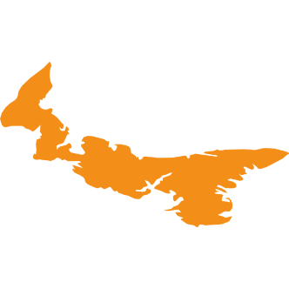

#### 1750s-1900s 1920s – 1940s 1950 – 1990s 2000s

### Early History

* In 1758, potato was first introduced to PEI.
* In 1827, PEI’s potato was exported for the

first time.

### Modernization

* Development of the seed potato industry and polices to control potato diseases
* Introduction of Irish

### Large-Scale

* + Large-scale mechanization was introduced to potato farming in PEI.
  + Number of individual

### Worldwide

* PEI ranks first in potato production in Canada.
* PEI potato products are shipped to over

Cobbler and the Green Mountain.

potato growers started to decrease.

40 countries.

*Figure 1: PEI potato development timeline*

## PEI Potato by the Numbers

The iron-rich soil, warm summer, cold winter and adequate precipitation rates make PEI an ideal place to grow potatoes in Canada, and to maximize yields, production and tuber quality (Gupta, 1991; MacFadyen, 2016). Due to continued innovation, research and good farming practice, the average potato yield per harvested acres in PEI has more than tripled over the years. The average yield by harvested acre is considered the best measure of endpoint productivity. In 1920, producers in PEI could expect a yield average of about 100 hundredweight (Cwt)1 per harvested acres, this number has dramatically increased to reach 300 Cwt in 2019. Figure 1 shows the growth in PEI potato yield and production between 1920 and 2019 (Statistics Canada, 2019a).

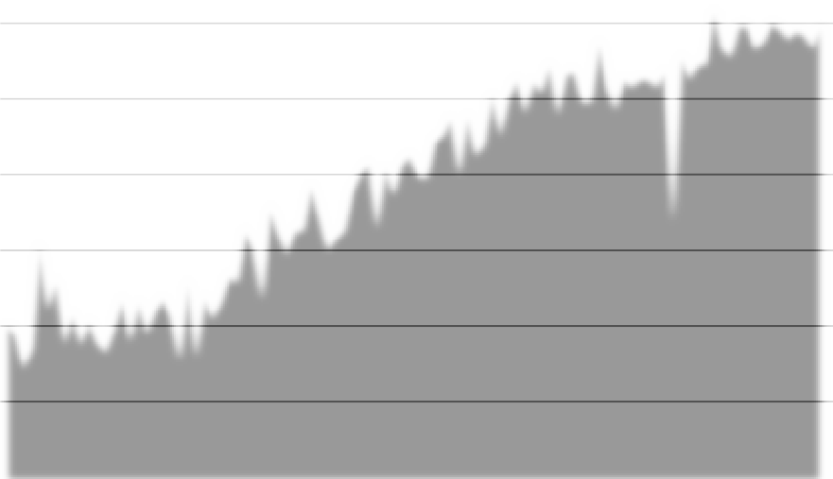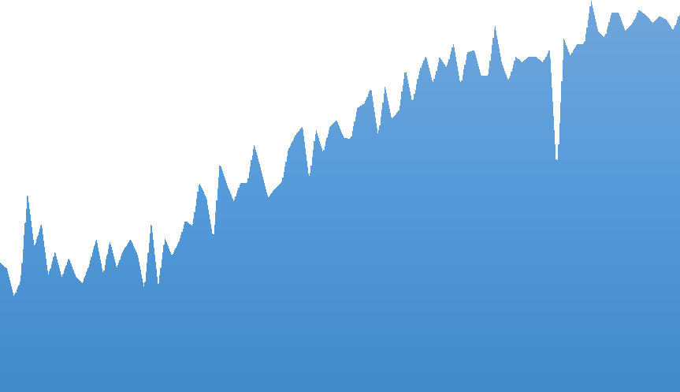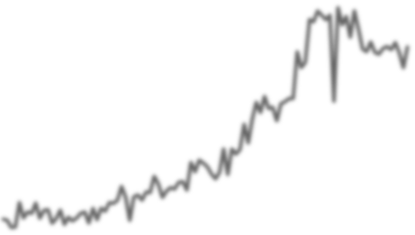

Production (Million Cwt )

Average yield (Cwt per harvested acres)

0.00

0

4.10

50

8.20

100

12.30

150

16.40

200

20.50

250

28.70

24.60

300

32.80

350

Average yield (Cwt per harvested acres)

Production ( Million Cwt )

Source: Statistics Canada (2019a).

1920

1923

1926

1929

1932

1935

1938

1941

1944

1947

1950

1953

1956

1959

1962

1965

1968

1971

1974

1977

1980

1983

1986

1989

1992

1995

1998

2001

2004

2007

2010

2013

2016

2019

*Figure 2: PEI potatoes yield (average) and production, 1920-2019*

PEI’s geographic area is 1.4 million acres, making it the smallest province in Canada. Despite PEI’s small size, it is Canada’s largest producer of potatoes. In 2019, PEI had 85,500 acres of land devoted to potato production, representing the largest share of Canada’s potato acreage (Statistics Canada, 2019a; Statistics Canada, 2018a). PEI’s acreage of potatoes are concentrated in the western part of the island; Prince County is PEI’s top potato-producing county,, accounting for over 62% of PEI’s total potato acres (Figure 3) (Statistics Canada, 2016a).

1 A hundredweight is a unit of measurement equals to 100 pounds (Chen, 2019).

**22**

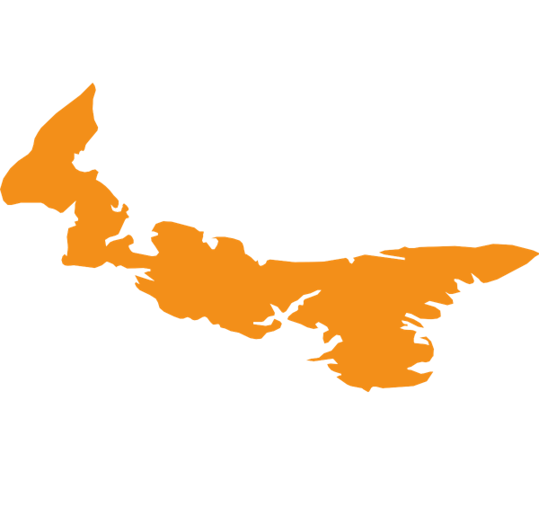

**%**

##### Prince

##### 62 Queens Kings

**%**

**16**

Source: Statistics Canada (2016). **%**

*Figure 3: PEI potato acreage by County*

With enhancements in farming practice, potato production in PEI has continued to grow over time. PEI has been Canada’s largest potato-producing province since 1976 (Statistics Canada, 2019a). Potato production in PEI averaged 24.7 million Cwt between 2010 and 2019, representing 24% of Canadian potato production. Figure 4 shows potato production share by province (average, 2010-2019). Potato seeded acreage peaked in 1997 at 112,000 acres and then gradually decreased to 85,000 in 2010 and has been relatively stable since then (Statistics Canada, 2019a). The decrease in potato seeded acreages has not impacted output, reflecting improved productivity.

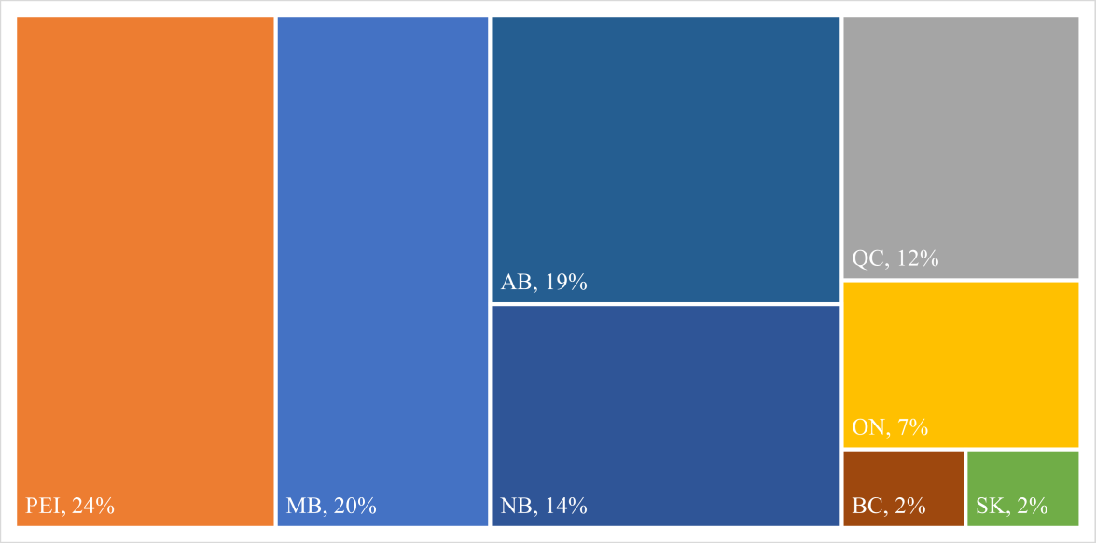

24,768 million Cwt

20,432 million Cwt

18,902 million Cwt

11,762 million Cwt

7,475 million

14,607 million Cwt

Source: Statistics Canada (2019a).

*Figure 4: Potato production share by province (average 2010-2019)*

PEI is expected to remain the largest potato-producing province in the coming years and continue to lead all Canadian provinces in potato production (Watters, 2018). However, the increased area planted with potato in Manitoba and Alberta, coupled with both the expansion of potato processing capacity in both provinces and greater flexibility in responding to weather-related challenges, point to Manitoba and Alberta emerging as Canada’s leading potato producers in the future (Watters, 2018).

Potatoes are the number one source of farm revenue from crops in PEI (Figure 5), making it a key contributor to farm profitability. In 2019, PEI had 182 farms classified as potato farms (AAFC, 2019). By farm cash receipts, potato farming is more important to the PEI economy than any other province in Canada. On average, between 2009 and 2018, potato represented 78% of total PEI crop cash receipts, while it represented 7% and 3% of Manitoba’s and Alberta’s total crop cash receipts respectively, (Figure 6). This reflects the important role of the potato sector in PEI (Statistics Canada, 2018b).



|  |  |  |  |
| --- | --- | --- | --- |
| Fruit |  |  | 10 |
|  |  |  |  |
| Vegetables |  |  | 13 |
| Corn |  |  |  |
| Soybeans |  |  | 15 |

|  |  |  |
| --- | --- | --- |
| BC |  | 3% |
| AB |  | 3% |
|  |  |  |
| MB |  | 7% |
| ON |  | 2% |

Source: Statistics Canada (2018b)



3

Barley 10

Wheat 6

Potatoes

236

0

50 100 150 200 250



QC

5%

NB

48%

PEI

78%

0%

20% 40% 60% 80% 100%

*Figure 5: PEI crop cash receipts (Average 2009- 2018, million CAD)*

Source: Statistics Canada (2018b)

*Figure 6: Potato cash receipts share of total crop receipts by province (average 2009-2018)*

The Net Operating Income (NOI) of potato farms in PEI increased over the past years. In 2019, the average NOI of a potato farm in PEI was $376,917, an increase from $65,300 in 2007. Potato farms expense-to-receipt ratio2 has improved. PEI potato farms have the most favorable ratio relative to other crop farms (e.g., grains, oilseeds and vegetables). In 2019, potato farms in PEI had an expense-to-receipt ratio of 0.79 (for every dollar in receipts, farms had 79 cents in expenses), compared with 0.92 in 2007, reflecting an improvement in profitability of potato farm operations (AAFC, 2019). Figure 7 shows the average total revenue and expenses and average NOI of potato farms in PEI between 2007 and 2019.

2 The average amount incurred in operating expenses for a dollar in gross farm receipts (Statistics Canada, 2018c).

Average NOI (Thousand CAD)

Source: AAFC (2019).

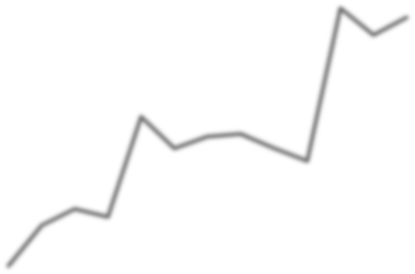

Net operating income

Program payments

Total operating expenses

Market receipts

2007 2008 2009 2010 2011 2012 2013 2014 2015 2016 2017 2018 2019

0

0

50

200

100

400

150

600

200

800

250

1,000

300

1,200

350

1,400

400

1,600

450

1,800

Average market receipts, prgram payments and total expenses (Million CAD)

*Figure 7: Average farm market receipts, program payments, total expenses and NOI (2007 - 2019)*

## PEI Potato Utilization

PEI Potato Board statistics show that 60% of PEI’s potatoes are used for processing, about 25% of PEI’s potatoes are used for the fresh market (table potatoes), and 15% are used as seeds for next year potato crop (Figure 8).

The majority of PEI’s processing potatoes are sold to Cavendish Farms Corporation, which primarily processes and supplies frozen potato products such as French fries, wedges, and hash browns. Cavendish Farms is the 4th largest processor of frozen potato products in North America (Cavendish Farms Corp, 2019). Cavendish Farms opened in PEI in 1980 after Irving Group purchased the Mclean potato and vegetable processing facility in PEI and renamed it Cavendish Farms. In 1996, Cavendish Farms constructed its second processing facility in PEI. In 2017, it opened a new 50 million pound refrigerated storage unit (Cavendish Farms Corp, 2019).

In addition to potatoes for Cavendish Farms, potatoes move on and off-island to dehydration plants. Fresh potatoes are sent off-island for processing at regional french fry and potato chip processing plants and to off-shore markets to be used for potato chip processing (PEI Potato Board, personal communication, October 9, 2020).

The fresh potato market has been stable in recent years. Producers have been making significant changes to meet consumer demand and preferences. There has been an upward trend in the red and yellow potato segments. The organic market has stabilized over the past five years, but the volume of specialty/creamer type potatoes continues to grow and the volume is 8 times what it was 10 years ago (PEI Potato Board, personal communication, October 9, 2020).

Eighty percent of Island grown seed potatoes are used locally. Processing demand impacts the seed sector, as processing acres determine the amount of seed required for planting. The off-island demand also contributes to the strength of this segment. Island growers send seed to the US market as well as over 11 other countries around the world (PEI Potato Board, personal communication, October 9, 2020).





**60**%

Processing

Table potatoes



**25**%

**15**%

Seed potatoes



Source: PEI Potato Board, 2018.

*Figure 8: PEI potatoes utilization*

## PEI Potato Exports

The PEI potato sector is export-oriented (nationally and internationally). The vast majority of PEI’s potatoes and potato products are exported to other provinces or abroad. PEI’s potatoes represents 23% of Canada’s total international potatoes exports (average, 2009-2018). Together, PEI and Manitoba account for about 50% of Canada’s potato exports (Figure 9).



**26**%

Manitoba

**23**%

Prince Edward Island

**21**%

Alberta

**19**%

New Brunswick

|  |  |  |
| --- | --- | --- |
| **Province** | **International exports (Million CAD) Average (2009-2018)** | **Share (%)** |
| Manitoba | 351 | 26.20 |
| Prince Edward Island | 311 | 23.11 |
| Alberta | 284 | 21.38 |
| New Brunswick | 261 | 18.99 |
| Ontario | 80 | 6.66 |
| Quebec | 34 | 2.45 |
| Saskatchewan | 5 | 0.41 |
| British Columbia | 8 | 0.59 |
| Nova Scotia | 3 | 0.20 |

*Source: Global Trade Tracker (2019).*

*Figure 9: Potato international exports by province (Average 2009-2018)*

Although PEI international exports consist of a diverse range of agri-food products, fresh and processed potatoes are the majority of PEI’s agri-food exports. Potatoes sales represent 89% of PEI’s total international agri-food exports (average, 2009-2018). The United States (US), Trinidad and Tobago, Thailand, South Korea and Jamaica are the top importers of PEI’s potatoes (Global Trade Tracker, 2019).

The eastern location of PEI, which is close to the highly populated east coast of the US, plays an important role in the success of PEI’s potato sector and continues to provide opportunities for the sector to grow. This can be observed by the size of potato exports to the US which represents 84% of PEI’s total international potato exports (average, 2009-2018). Trade data shows that processed potatoes represent, on average, 78% of PEI’s potato exports, while fresh potatoes and seed potatoes represent 20% and 2%, respectively (Global Trade Tracker, 2019). Figure 10 below shows PEI’s processed, fresh and seed potato international exports between 2009 and 2018.



450

400

350

300

250

200

150

100

50

0

2009 2010 2011 2012 2013 2014 2015 2016 2017 2018

Total Processed potato Fresh potato Seed potato

(Million CAD)

Source: Global Trade Tracker (2019).

*Figure 10: PEI's potato exports to the US, 2009-2018*

# Contribution of Potatoes to PEI’s Economy

As with any other sector, the potato sector in PEI does not exist in isolation. A chain of industries forms a potato industrial complex of linked buyers and sellers. The industries that supply inputs are “backward linked”. The industries to which goods and services are sold are “forward linked” (Tayler et al., 2007). Potato farming is at the center of the potato sector. Backward linked industries include: accounting services, fertilizer suppliers, fuel distributers and other inputs. Forward linked industries include the fresh packers and dehydration and frozen products processors.

The contribution of the potato sector to PEI’s economy can be estimated using two measures: *sector size* and *sector impact*. Size is measured by conventional statistics, while impact is measured by the linkages of the potato sector to other industries. The later measure requires looking at and incorporating all the economic activities of other industries related to potato sector. To this end, Economic Impact Analysis (EIA) can be utilized to measure the sector’s role in the economy in terms of jobs, sales, income and other economic indicators that are directly or indirectly created by business activity related to PEI’s potato sector.3

## Sector Size

The conventional statistics discussed in the previous sections show that the contribution of potato sector to PEI’s economy is substantive. However, analyzing the economic impact of the sector cannot be fully captured without examining the linkages between industries and tracing the impact through the value- added chain. For instance, potato farming requires machinery, fertilizers and pesticides, labour, etc. On the other hand, potato processing is an important link in the supply chain. Processing requires services. Assessing the additional contribution of potato processing beyond potato farming is essential in evaluating the potato sector’s overall contribution to PEI’s economy. Hence, conventional statistics alone cannot provide a comprehensive view of the potato sector’s role in PEI economy.

## Sector Impact

EIA is a methodology for evaluating the impacts of a sector on the economy of a specified region. This analysis supports decision-making and provides a measure of strategic analysis. The EIA quantifies the flows of economic activities associated with an economic sector/activity. There are several EIA models that can be used to evaluate a project or an economic sector. The Input-Output (I-O) is widely used to examine the economic impact of a specific sector and is utilized in this study (Miller & Blair, 2009).

3 This analysis does not include environmental impact analysis of the potato sector, Therefore, any costs that could be incurred by resource mismanagement or environmental damage is not measured in this study.

For the purposes of this study, PEI’s potato sector includes: (i) potato farming and (ii) potato processing. All backward and forward linkages4 of potato farming and processing were included in the analysis to capture the sector’s entire impact (Figure 11). Potato farming backward linkages include seed, fertilizer, labour and machinery operating expenses. Major forward linkage sales categories are on-Island sales to processors, packing sheds and fresh, seed markets, packaging and transportation, and off-island sales of potatoes including exports (Canmac Economics Limited , 2011). Potato processing backward linkages include fresh potato, packaging materials, power, etc. Main forward linkages include on-island and off-island sales of processed potato.

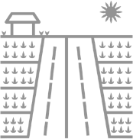

Potato farming

Potato processing

*Figure 11: Conceptual framework economic analysis of PEI's potato sector*

4 Linkages can be divided into backward and forward linkages (up-stream and down-stream linkages). Backward linkages refer to linkages from the farm/processor to the part of the non-farm/non-processing sectors that provides inputs for production. Forward linkages refer to the part of the non-farm/processing sectors that uses output (Davis et al., 2002).

# Approach and Methodology

In this study, economic impact was estimated using Statistics Canada 2016 I-O tables. I-O models are quantitative economic models that represent the interdependences between different sectors in an economy (United Nations, 2018). The model was utilized to measure PEI’s potato sector impact on PEI and Canada5 economies in terms of output, Gross Domestic Product (GDP), labour income, employment and taxes.

The estimates are based on a one-time shock using I-O model. This study focus on the economic activities that are supported in PEI from potato production and processing. The impact of PEI’s potato sector on the rest of Canada was calculated separately.

To capture the entire economic impact of the potato sector on PEI’s economy, this study accounted for three types of economic impacts: direct, indirect, and induced effects as described below (Pleeter, 1980):

* Direct economic impact: accounts for activities related directly to the operation of the potato sector in PEI. Through this category, all impacts generated due to direct activities are captured (e.g. expenditures incurred by potato farmers, processors, etc.)
* Indirect economic impact: accounts for the impacts that affect other industries and are linked to the potato sector (business-to-business). For instance, this captures how machinery provider spends the revenue received from producers.
* Induced impact: accounts for impacts generated through the re-spending of income earned by the participants in the direct and indirect components of the direct and indirect expenditure. Induced impacts arise from re-spending that occurs in the economy at the household level (e.g., employees of potato processors using their income to purchase goods and services).
* Total impact: equals the sum of the direct, indirect, and induced economic impacts.

5 The impact of PEI’s potato sector on the rest of Canada was calculated separately.

An I-O model allows for estimating the economic impact of the PEI’s potato sector on output, GDP, employment, wages and tax generation. Figure 12 shows the three categories of the EIA.

Wages spent on private consumption

Direct impact

Indirect impact

Induced impact

       

Farms

Processors

Supporting businesses

Retail Housing Restaurants

Purchases from suppliers (business- to-business)

Suppliers employees’ wages spent on private consumption

*Figure 12: Economic impact analysis categories*

Using I-O analysis allows tracking the economic impact of potato sector throughout the supply chain for both production and processing sectors. Such detailed analysis can help drive insights into the extent of the impact on supplier industries.

## Statistics Canada Input-Output Tables

The I-O tables show the inter-industry transactions. I-O tables show all purchases of an industry from all other industries, as well as all expenditures on primary inputs. Statistics Canada’s I-O tables are published annually at national and provincial levels. The symmetric I-O Tables, also known as Input tables, are derived from the “Supply” and “Use” tables. I-O tables allow one to answer "what if?" questions at a detailed level to explore the impact of changes in final demand on output, while taking into account the interdependencies between industries (Statistics Canada 2019b). For example, the potato sector purchases intermediate inputs from other economic sectors to produce.

The part of PEI’s supply and use table used in building the I-O analysis model is shown in Figure

13. The I-O table captures the relationship between producers, consumers and interdependencies of industries for the year 2016. The symmetric I-O table in this illustration shows the way industries interact with one another and produce for consumption and investments. Figure 13 shows the basic structure of the

supply-use table. The rows represent the outputs (suppliers), and the columns are the destination of inputs (users).

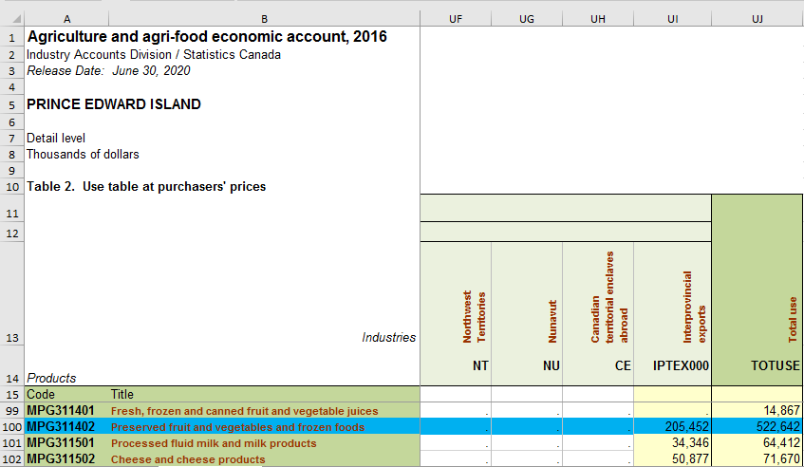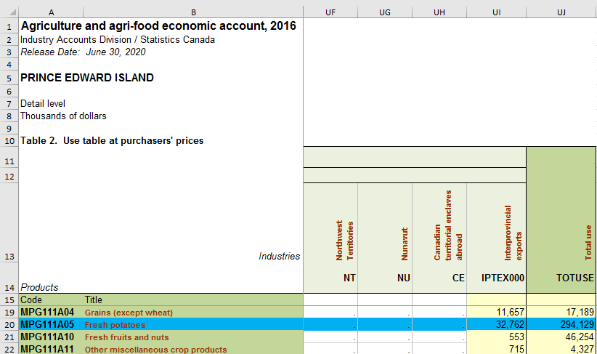

*Figure 13: Illustration of PEI’s supply-use table*

## Multipliers

The I-O multipliers are derived from the supply and use tables. Multipliers provide a measure of the interdependence between an industry and the rest of the economy (Statistics Canada, 2020a). I-O multipliers are summary measures used for predicting the total impact on all industries in an economy of changes in the demand for the output of any one industry. The standard I-O model was used to calculate the I-O multipliers. The output multiplier for the industry is defined as the total value of production by all industries of the economy required to satisfy one extra dollar's worth of final demand for that industry's output (Miller & Blair, 2009).

Two types of multipliers were used to determine economic impact in this study, “Type I Multipliers” and “Type II Multipliers”. 6 When the impacts generated through the re-spending of income earned on consumption is included, a Type II Multiplier is generated (i.e., the direct, indirect and induced impacts). When the impact generated through re-spending of households is excluded, a Type I Multiplier (i.e., direct plus indirect impact) is generated (Miller & Blair, 2009).

6 See Appendix A for details on Type I and Type II multipliers.

# Potato Sector Economic Impact Analysis Results

This section reports three categories of economic impacts (i.e., direct, indirect, and induced impacts) on output, GDP, employment, income and government tax revenue. These impacts represent how the sector’s operations and capital investments ripple throughout the PEI and Canada economies (Statistics Canada, 2020).

* Output: the total gross value of goods and services produced by the potato sector (i.e., production and processing) measured by producers’ price. This is the broadest measure of economic activity.
* GDP7: refers to the additional value of GDP that the potato sector adds to PEI and Canada economies.
* Labour Income: refers to the labour income generated by PEI’s potato sector in PEI and Canada.
* Employment is the number of additional jobs created by PEI’s potato sector in PEI and Canada. Employment is measured in terms of Full Time-Equivalent (FTE)8. FTE jobs include only employee jobs that are converted to full-time equivalence based on the overall average full-time hours worked in either the business or government sectors.
* Government tax revenues: are the total amount of tax revenues generated for different levels of government (i.e. federal provincial etc.).

Tables 1 to 4 below summarize the economic impact of PEI’s potato sector on PEI and Canada economies in terms of output, GDP, labour income and employment9 and Table 5 summarizes the amount of tax revenues generated by the PEI’s potato sector.

## Output

Table 1 shows that the PEI potato sector in 2016 (i.e., farming and processing) supported $1.35 billion dollars in sales in PEI, $544.7 million dollars in other Canadian provinces, which sum to a total of

$1.89 billion dollars in sales for all Canada. These sales include the potato revenue ($761 million direct

7 The value of economic output includes the value of tangible goods as well as new construction and services (Miller & Blair, 2009).

8 Is defined as total hours worked divided by average annual hours worked in full-time jobs (Statistics Canada, 2015).

9 Appendix B includes a detailed summary of the EIA of PEI’s potato sector at two separate level (i.e., farm and processing).

impact) as well as the sales generated by the businesses that supply the potato sector and the labor income it creates. On a per capita basis, the potato sector generates approximately $9,435 in sales per PEI resident, based on 2016 population10.

*Table 1: PEI’s potato sector impact on output, 2016 (Thousand CAD)*

|  |  |  |  |
| --- | --- | --- | --- |
| Impact | Contribution to PEI ‘s Economy | Contribution to Other Canadian Provinces | Total (National) contribution |
| Direct | 761,029 | 14,150 | 775,178 |
| Indirect | 490,617 | 374,473 | 865,090 |
| Induced | 96,735 | 156,096 | 252,830 |
| ***Total*** | ***1,348,381*** | ***544,718*** | ***1,893,099*** |

Source: I-O simulation, Strategic Policy and Evaluation, Department of Agriculture and Land.

## GDP

The sector’s value to the economy is measured by GDP. At the provincial level, direct GDP generated by PEI’s potato sector was estimated at $225.5 million and supported $238.3 million in indirect and 63.4 million in induced GDP impact which total to $527.1 million. Nationally (i.e., combining the impact on PEI and other Canadian provinces) $784.6 million was added to Canada’s economy by PEI’s potato sector, Table 2 summarizes PEI’s potato sector impact on the GDP in 2016.

*Table 2: PEI’s potato sector impact on GDP, 2016 (Thousand CAD)*

|  |  |  |  |
| --- | --- | --- | --- |
| Impact | Contribution to PEI ‘s Economy | Contribution to Other Canadian Provinces | Total (National) contribution |
| Direct | 225,457 | 5,463 | 230,920 |
| Indirect | 238,260 | 169,536 | 407,796 |
| Induced | 63,410 | 82,498 | 145,909 |
| ***Total*** | ***527,127*** | ***257,497*** | ***784,624*** |

Source: I-O simulation, Strategic Policy and Evaluation, Department of Agriculture and Land.

## Labour Income

The analysis shows that PEI’s potato sector adds significantly to wages within the province and across Canada. In 2016, PEI’s potato sector generated $240 million in income in the province and $378 million in Canada (including PEI). At the provincial level, $225.5 million in income was generated due to

10 In 2016, PEI’s population totaled 142,907 (Statistics Canada, 2016c)

direct employment in the potato sector, while $238.3 million generated by employment in supporting industries (indirect impact) and $63.4 million as a result of spending on consumption (induced impact). Table 3 below summarizes the impact of PEI’s potato sector on labour income at the provincial and national levels.

*Table 3: PEI’s potato sector impact on labour income, 2016 (Thousand CAD)*

|  |  |  |  |
| --- | --- | --- | --- |
| Impact | Contribution to PEI ‘s Economy | Contribution to Other Canadian Provinces | Total (National) contribution |
| Direct | 89,367 | 3,173 | 92,540 |
| Indirect | 126,347 | 93,554 | 219,901 |
| Induced | 24,237 | 41,455 | 65,693 |
| ***Total*** | ***239,951*** | ***138,183*** | ***378,134*** |

Source: I-O simulation, Strategic Policy and Evaluation, Department of Agriculture and Land.

## Employment

In 2016, PEI’s potato sector impact led to the creation of 5,016 FTE jobs in PEI, 2,086 FTE jobs in other Canadian provinces; a total of 7,086 FTE jobs in Canada (including PEI). PEI’s potato sector maintains more indirect jobs than direct or induced in PEI and Canada. Table 4 summarizes PEI’s potato sector impact on employment.

*Table 4: PEI’s potato sector impact on employment, 2016 (FTE)*

|  |  |  |  |
| --- | --- | --- | --- |
| Impact | Contribution to PEI ‘s Economy | Contribution to Other Canadian Provinces | Total (National) contribution |
| Direct | 1,768 | 50 | 1,818 |
| Indirect | 2,785 | 1,385 | 4,170 |
| Induced | 463 | 635 | 1,098 |
| ***Total*** | ***5,016*** | ***2,070*** | ***7,086*** |

Source: I-O simulation, Strategic Policy and Evaluation, Department of Agriculture and Land.

## Taxes

In 2016, $48.9 million of federal, provincial and municipal taxes were collected in PEI as a result of the potato sector (including taxes on all activities directly or in directly related to PEI’s potato sector). Nationally, tax revenues totalled $73.2 million at different levels of government. Table 5 below summarizes tax revenues (federal, provincial and municipal) generated by PEI’s potato sector at provincial and national levels.

*Table 5: Tax revenues generated by PEI’s potato sector, 2016 (Thousand CAD)*

|  |  |  |  |
| --- | --- | --- | --- |
| Tax | PEI | Other Canadian Provinces | Total |
| Federal | 9,093 | 4,236 | 13,329 |
| Provincial | 33,842 | 11,794 | 45,636 |
| Municipal | 5,970 | 8,254 | 14,224 |
| ***Total*** | ***48,905*** | ***24,300*** | ***73,205*** |

Source: I-O simulation, Strategic Policy and Evaluation, Department of Agriculture and Land.

## Potato Sector in PEI’s Economic Context

PEI’s potato sector is a significant contributor to PEI’s economy and an important addition to the Canadian national economy. To put the EIA results in context, Table 6 summarizes PEI’s potato sector size/contribution relative to the whole of PEI’s economy in 2016.

*Table 6: PEI’s potato sector contribution relative to whole PEI’s economy, 2016*

|  |  |  |  |
| --- | --- | --- | --- |
| Economic indicator | Total | Potato sector | Potato sector as a percentage of total |
| Total output (Thousand CAD ) | 10,342,779 | 1,348,381 | 13% |
| GDP (Thousand CAD ) | 5,803,360 | 527,127 | 9.1% |
| Labour income (Thousand CAD) | 2,733,429 | 239,951 | 8.8% |
| Full-time jobs (Persons)11 | 59,300 | 5,016 | 8.5% |

Sources: Statistics Canada Supply and Use Tables.

Comparing the main economic indicators to the EIA of PEI’s potato sector results shows the importance of this sector to PEI’s economy. In 2016, the potato sector was responsible for 13% of the province’s total output, 9.1% of PEI’s GDP, 8.8% of the total labour income and it employed 8.5% of the total full-time employed persons in the province12. This study shows that PEI’s potato sector is an important contributor to PEI’s economy. Figure 14 below illustrates the potato sector’s role in PEI’s economy.

11 The number of persons who are full-time employed (Statistics Canada, 2020b) was used as a proxy for comparison purposes. The number of full-time employed person is not equivalent to FTE.

12 EIA studies on other major economic sectors in PEI, such as the seafood and tourism sectors, would allow for more comprehensive comparison.

Potato sector 13%

Other sectors 87%

Output

Potato sector 9.1%

Other sectors 90.9%

GDP

Potato sector 8.8%

Other sectors 91.8%

Labour income

Potato sector 8.5%

###### FTE Jobs

*Figure 14: PEI’s potato sector role in PEI’s economy*

Other sectors 91.5%

# Conclusions

The potato sector’s economic contribution was assessed by estimating sector impact on output, GDP, labour income, employment and taxes. The potato sector in PEI provides a significant contribution to both the province and the country as a whole. The sector’s economic contribution is generated through economic activity at the farm level, as well as from the industries that support farming activities, processing, and industries that support potato processing. Examples of these industries include fertilizer, financial service, and transportation etc.

This study provided a comprehensive analysis of the economic impacts of PEI’s potato sector on the province and the Canadian economies in 2016. The economic contributions of potato farming were estimated separate of potato processing. Potato processing is an important sector in PEI; it impacts the service industries that support their operations. The additional contribution of potato processing was

estimated for the PEI and Canadian economy so that the results could be combined to provide a detailed view of the contribution of the PEI’s potato sector.

The potato sector in PEI is a significant economic driver for the province. In 2016, through its direct, indirect and induced impacts, the sector generated $1.35 billion in PEI output, boosted the provincial GDP by over $527 million, created 5,016 FTE jobs and generated $48.9 million in taxes. Nationally (i.e., the impact on Canada’s economy including PEI), the analysis showed that PEI’s potato sector generated about $1.89 billion in output, boosted the national GDP by $784.6 million, created 7,086 FTE jobs, and generated over $73 million in taxes.

From a policy perspective, policies are needed to support projects that enhance the sustainability of the potato sector in PEI, given that it is a vital economic driver of the province’s economy. These projects might include research to enhance economic growth of this sector and invest in promoting PEI’s potato nationally and internationally to a diverse range of markets. It is also important to ensure that regulations that may be affecting growth and investment returns in the sector activities have been carefully examined to protect the environment and ensure sustainable economic growth. From a diversification perspective, it is important for PEI’s potato sector to move to a more diverse production and trade structure and to invest in exploring new international markets. A lack of diversification increases the sector’s vulnerability to external shocks.

# References

Agriculture and Agri-Food Canada. (2019). *Average farm income by selected farm type, Prince Edward Island* [Database]. Retrieved from [http://www5.statcan.gc.ca/cimt-cicm/home-accueil?lang=eng.](http://www5.statcan.gc.ca/cimt-cicm/home-accueil?lang=eng)

Campbell, M. & Keefe, H. (2008). T*he History of Agriculture (Farming) on Prince Edward Island*.

Retrieved from [http://culturesummerside.com/assets/Program-The-History-of-Agriculture.pdf.](http://culturesummerside.com/assets/Program-The-History-of-Agriculture.pdf)

Canmac Economics Limited. (2011). PEI Potato Industry – An Economic Impact and Strategic Direction Assessment.

Cavendish Farms Corp. (2019). *Product Listing*. Retrieved from https://cavendishfarms.com/en/ca/for- foodservice/products/.

Chen, J. (2019). *Hundredweight (Cwt)*. Retrieved from https://[www.investopedia.com/terms/h/hundredweight.asp.](http://www.investopedia.com/terms/h/hundredweight.asp)

Davis, B., Reardon, T., Stamoulis, K., Winters, P. (2002). Promoting Farm/Non-Farm Linkages for Rural Development - Case Studies from Africa and Latin America. Retrieved <http://www.fao.org/3/y4383e/y4383e00.htm#Contents>

Discover Charlottetown. (2019). *All Your Burning Questions about PEI Potatoes Answered!*. Retrieved from https://[www.discovercharlottetown.com/blog/all-your-burning-questions-about-pei-](http://www.discovercharlottetown.com/blog/all-your-burning-questions-about-pei-) potatoes-answered/.

Global Trade Tracker. (2019). [Database]. Retrieved from [https://www.globaltradetracker.com/start/index.php/services/trade-data.](https://www.globaltradetracker.com/start/index.php/services/trade-data)

Gupta, U. C. (1991). Iron status of crops in Prince Edward Island and effect of soil pH on plant iron concentration. *Canadian Journal of Soil Science*. *7*(2), 197-202. [https://doi.org/10.4141/S98-033.](https://doi.org/10.4141/S98-033)

MacDonald, E*.*(2000). *If You’re Stronghearted: Prince Edward Island in the Twentieth Century*.

Charlottetown: Prince Edward Island Museum and Heritage Foundation.

MacFadyen, J. The Fertile Crescent: Agricultural Land Use on Prince Edward Island, 1861-1971. In E. MacDonald, J. MacFadyen, and I. Novaczek (Ed.), *Time and a Place: An Environmental History of Prince Edward Island* (pp. 61-194). Montreal: McGill-Queen’s University Press.

Millar, R.E. and Blair, P.D. (2009). Input-Output analysis: foundations and Extensions. New York, NY: Publisher City, State: Cambridge University Press.

Pleeter S. (1980) Methodologies of Economic Impact Analysis: An Overview. In: Pleeter S. (eds) Economic Impact Analysis: Methodology and Applications. Studies in Applied Regional Science, vol 19. Springer, Dordrecht. <https://doi.org/10.1007/978-94-011-7405-3_2>

Statistics Canada. (2015). *Glossary of terms*. Retrieved from https://www150.statcan.gc.ca/n1/pub/13- 604-m/2012070/gloss-eng.htm.

Statistics Canada. (2016a). Table: 32-10-0416-01 (formerly CANSIM 004-0213)-*Hay and field crops*, CANSIM [Database]. Retrieved

from https://www150.statcan.gc.ca/t1/tbl1/en/cv.action?pid=3210041601

Statistics Canada. (2016b). Table: 32-10-0403-01 (formerly CANSIM 004-0200) - *Farms classified by farm type*, CANSIM [Database]. Retrieved from https://www150.statcan.gc.ca/t1/tbl1/en/cv.action?pid=3210040301

Statistics Canada. (2016c). Census Profile, 2016 Census. Retrieved from https://www12.statcan.gc.ca/census-recensement/2016/dp- pd/prof/details/page.cfm?Lang=E&Geo1=PR&Code1=11&Geo2=PR&Code2=01&SearchText= Canada&SearchType=Begins&SearchPR=01&B1=All&type=0.

Statistics Canada. (2018a). *Prince Edward Island has the largest potato crop in Canada*. Retrieved from https://www150.statcan.gc.ca/n1/pub/95-640-x/2016001/article/14801-eng.htm.

Statistics Canada. (2018b). Table: 32-10-0045-01 (formerly CANSIM 002-0001) - *Farm cash receipts, annual (x 1,000)*, CANSIM [Database]. Retrieved from <https://www150.statcan.gc.ca/t1/tbl1/en/cv.action?pid=321000450>.

Statistics Canada. (2018c). *Farm and Farm Operator Data*. Retrieved from https://www150.statcan.gc.ca/n1/pub/95-640-x/2016001/article/14815-eng.htm.

Statistics Canada. (2019a). Table: 32-10-0358-01 (formerly CANSIM 001-0014) - *Area, production and farm value of potatoes*, CANSIM [Database]. Retrieved from https://www150.statcan.gc.ca/t1/tbl1/en/tv.action?pid=3210035801&pickMembers%5B0%5D=1. 3&cubeTimeFrame.startYear=2016&cubeTimeFrame.endYear=2020&referencePeriods=201601 01%2C20200101

Statistics Canada. (2019b). *Supply, Use and Input-Output Tables*. Retrieved from https://www23.statcan.gc.ca/imdb/p2SV.pl?Function=getSurvey&SDDS=1401.

Statistics Canada. (2020a). *National and Provincial Multipliers*. Retrieved from https://www150.statcan.gc.ca/n1/en/catalogue/15F0046X.

Statistics Canada. (2020b). 14-10-0090-01 (formerly CANSIM 282-0123)- *Labour force characteristics by province, territory and economic region, annual (x 1,000)*, CANSIM [Database]. Retrieved from https://www150.statcan.gc.ca/t1/tbl1/en/cv.action?pid=1410009001.

Trade Data Online. (2019). *Canadian International Merchandise Trade Database* [Database]. Retrieved from [http://www5.statcan.gc.ca/cimt-cicm/home-accueil?lang=eng.](http://www5.statcan.gc.ca/cimt-cicm/home-accueil?lang=eng)

Watters, A. (2018). Canada: Potatoes and Potato Products Annual 2018. Retrieved from https://apps.fas.usda.gov/newgainapi/api/report/downloadreportbyfilename?filename=Potatoes%2 0and%20Potato%20Products%20Annual%202018_Ottawa_Canada_9-24-2018.pdf.

# Appendices

## Appendix A: Type I and Type II Multipliers Calculation

Type I and Type II multipliers are used to determine economic impact. Type I Multipliers sum together direct and indirect effects while Type II Multipliers also include induced effects.

Type I and Type II multipliers can be calculated for output, GDP, employment, etc. In this example, output Type I and Type II multipliers are calculated for demonstration purposes. The first step to calculate Type I and Type II multipliers is to calculate Type I Inverse Matrix. This can be done as the following (Miller & Blair, 2009):

𝐿 = (1 − 𝑇)−1

Where:

L: is Leontiff Inverse Matrix

I: is Identity matrix (all the elements of the principal diagonal are ones, and all other elements are zeros). This matrix is known as transformation matrix.

T: is a technical coefficients matrix that derived by dividing each cell of the domestic intermediate demand.

Type I Leontief inverse matrix in constructed by subtracting the technical coefficient matrix (T) from Identity matrix and invert. Type I Leontief inverse matrix reflects the direct and indirect economic impact; household spending is not taken into account in this calculation (i.e., the spending of households take place outside the model).

Type II Leontief inverse matrix in constructed in the same way as Type I inverse matrix, but household spending is incorporated in this calculation. Household spending is treated as a separate industry in the model. This is done by adding extra rows and columns in the transformation matrix T.

## Appendix B: Detailed Summary of the EIA of PEI’s potato sector

*PEI's potato production (farming) economic impact, 2016*

|  |  |  |  |
| --- | --- | --- | --- |
|  | Contribution to PEI ‘s Economy | Contribution to Other Canadian Provinces | Total (National) contribution |
| Output (Million CAD) | |  |  |
| Direct | 293,563 | 923 | 294,486 |
| Indirect | 248,052 | 144,379 | 392,431 |
| Induced | 42,548 | 64,459 | 107,007 |
| ***Total*** | ***584,163*** | ***209,761*** | ***793,924*** |
| GDP (Million CAD) | | | |
| Direct | 56,118 | 502 | 56,620 |
| Indirect | 120,829 | 66,705 | 187,534 |
| Induced | 27,892 | 33,870 | 61,762 |
| ***Total*** | ***204,839*** | ***101,076*** | ***305,915*** |
| Labour income (Million CAD) | | | |
| Direct | 29,571 | 283 | 29,854 |
| Indirect | 63,063 | 36,451 | 99,514 |
| Induced | 10,660 | 17,102 | 27,762 |
| ***Total*** | ***103,295*** | ***53,836*** | ***157,130*** |
| Employment | | | |
| Direct | 722 | 5 | 727 |
| Indirect | 1,416 | 531 | 1,947 |
| Induced | 204 | 261 | 465 |
| **Total** | 2,341 | 797 | 3,138 |
| Taxes (Million CAD) | | | |
| Federal | 4,118 | 1,661 | 5,779 |
| Provincial | 16,947 | 4,664 | 21,611 |
| Municipal | 3,258 | 3,247 | 6,506 |
| ***Total*** | ***24,323*** | ***9,579*** | ***33,902*** |

Source: I-O simulation, Strategic Policy and Evaluation, Department of Agriculture and Land.

*PEI's potato processing economic impact, 2016*

|  |  |  |  |
| --- | --- | --- | --- |
|  | Contribution to PEI ‘s Economy | Contribution to Other Canadian Provinces | Total (National) contribution |
| Output (Million CAD) | |  |  |
| Direct | 467,466 | 13,227 | 480,693 |
| Indirect | 242,565 | 230,094 | 472,659 |
| Induced | 54,187 | 91,636 | 145,823 |
| ***Total*** | ***764,218*** | ***334,957*** | ***1,099,175*** |
| GDP (Million CAD) | | | |
| Direct | 169,339 | 4,961 | 174,300 |
| Indirect | 117,431 | 102,831 | 220,262 |
| Induced | 35,518 | 48,629 | 84,146 |
| ***Total*** | ***322,287*** | ***156,421*** | ***478,709*** |
| Labour income (Million CAD) | | | |
| Direct | 59,796 | 2,890 | 62,686 |
| Indirect | 63,284 | 57,104 | 120,387 |
| Induced | 13,577 | 24,353 | 37,930 |
| ***Total*** | ***136,656*** | ***84,347*** | ***221,003*** |
| Employment | | | |
| Direct | 1,046 | 45 | 1,091 |
| Indirect | 1,369 | 854 | 2,224 |
| Induced | 259 | 374 | 633 |
| ***Total*** | ***2,675*** | ***1,273*** | ***3,948*** |
| Taxes (Million CAD) | | | |
| Federal | 4,976 | 2,575 | 7,551 |
| Provincial | 16,895 | 7,130 | 24,025 |
| Municipal | 2,712 | 5,007 | 7,719 |
| ***Total*** | ***24,583*** | ***14,721*** | ***39,303*** |

Source: I-O simulation, Strategic Policy and Evaluation, Department of Agriculture and Land.

*[This page intentionally left blank]*